Raising of CSR by PIU-VSTF under SMART Project

Funding by Corporates through Village Social Transformation Foundation (VSTF) is one of the sources of funding to the SMART Project. These will be in nature of Corporate Social responsibility (CSR) funds. An amount of ten million dollars raised from Private sector has been committed by VSTF throughout the Project period. The activities identified by VSTF to be undertaken through these 10M USD fall under the component B1 and other identified components.
Indicative activities to be undertaken through CSR funds:
- Productive Partnership proposals
- Market Access plan proposals
- Complementary Innovation Investment proposals

VSTF Partners:
- Reliance Foundation
- Tata Trusts
- Mahindra Rise
- Siddhivinayak Trust
- JSW Foundation
- Chandra Foundation
- Stertile Technologies Ltd (STL)
- Swades Foundation
- Hindustan Unilever Ltd
- D Mart
- Axis Bank Foundation
- Wildlife Conservation Trust
- H T Parekh Foundation- An initiative by HDFC
- Rare Enterprises
- Deutsche bank
- ENAM
- Idea
- UNICEF
- Bal bharti

Current Status
- CSR Fund to be raised from Private Sector – Total: 10 Million USD
- Received Commitment letter from MAHINDRA: INR 14 Crores(over 6 years),
Received 4.30 Crores till date.

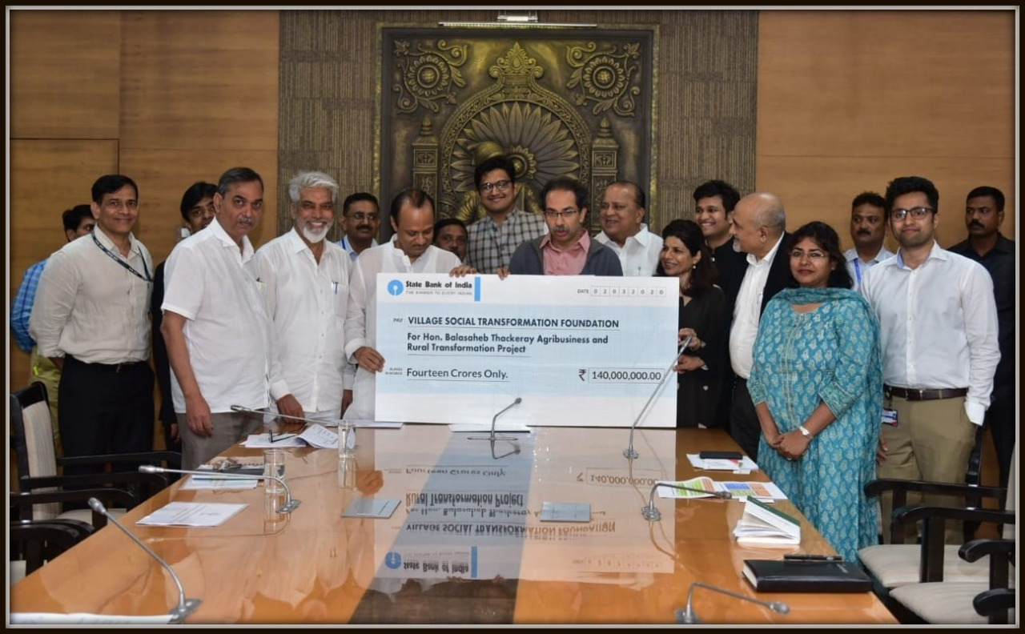
Mahindra and Mahindra Limited handed over a cheque of 2 crores in presence of Hon. CM, Hon. Dy CM, Hon. Minister Rural Development, and Hon. Minister Agriculture towards SMART project as 1st tranche of Mahindra’s commitment to donate Rs. 14 crores to VSTF on 13th March 2020.

